Assignment

1. Pseudocode and flowchart that converts all characters in any given string to capital letter

**PSEUDOCODE**

* 1. Tit ake an input string from the user (assuming It Is lowercase).
  2. Convert it to uppercase

**FLOWCHART**

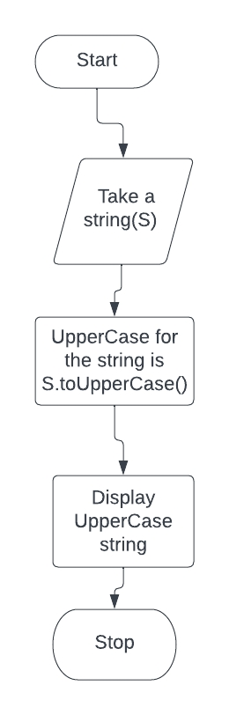

1. Given a string, write and design a pseudocode and flowchart to print the string in reverse order of the characters

**PSEUDOCODE**

* 1. The split() method splits a string object into an array of string by separating the string into substrings.
  2. The reverse() method reverses an array In place.
  3. The first array element becomes the last and the last becomes the first.
  4. The join(“ “)method joins all element of an array into a string.

**FLOWCHART**

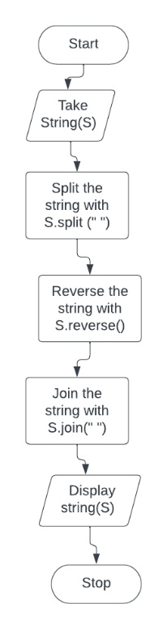

3. Pseudocode and flowchart that reminds a worker to clock in every hour

**PSEUDOCODE**

1. Start work
2. Input time to start work
3. Set interval
4. Input alert every 1 hour
5. Clear interval till 5pm
6. Stop

**FLOWCHART**